Award for Germany’s most innovative SMEs
PFLITSCH receives TOP 100 seal
PFLITSCH, the Hückeswagen-based family business, is one of Germany’s top innovators and has officially been authorised to use the TOP 100 seal since February 2023. During the anniversary round of the German SME Summit in Überlingen/Augsburg, the two managing partners Roland Lenzing and Mathias Stendtke proudly accepted the award on 23.06.2023.
For 30 years now, the award has specifically embodied the innovative strength of small and medium-sized enterprises. “We’re delighted to have been recognised in this way, and we see it as confirmation of our corporate policy and future focus”, said Roland Lenzing, Managing Partner at PFLITSCH. The judging panel’s independent verdict takes account not only of past successes but also of future-viable measures and projects. A comprehensive scientific innovation analysis is employed to assess all participants in five categories. PFLITSCH was able to convince the jury with top results in the categories “Climate of Innovation” and “Innovative Processes/Organisation” and received an award for " Innovation-friendly Senior Management". “The TOP 100 seal is a first-rate, reputation-enhancing testimonial. We’re honoured to have brought this award to Hückeswagen. We’d like to thank our entire PFLITSCH team: they are ultimately responsible for – and the key to – this success, and we’re more than happy to take on the challenge of further developing our innovative strength and hence our region as a business location”, explained co-Managing Partner Mathias Stendtke.
About PFLITSCH:
PFLITSCH is an internationally leading technology and service specialist when it comes to safe, reliable routing and protection of cables on an industrial scale. It was founded as a family business in 1919. Now in its fourth generation, the company stands for entrepreneurial spirit, innovative strength and customer orientation. More than 350 people are employed at PFLITSCH today. The firm was previously awarded the “Großer Preis des Mittelstandes” (SME Grand Prix) in 2021. PFLITSCH has also been honoured as the “Region’s Top Employer” as well as with the CoIC’s “Best Training Company” award, the berufundfamilie seal as a family-friendly company and REINER!, the Fraunhofer Institute’s clean technology award for the blueglobe cable gland in polyamide.

The TOP 100 competition:
Ever since 1993, compamedia has been awarding the TOP 100 seal for special innovative strength and above-average innovation success to medium-sized companies. Professor Nikolaus Franke has served as the competition’s scientific director since 2002. Franke is founder and director of the Institute for Entrepreneurship & Innovation at Vienna University of Economics and Business. With 26 research awards and more than 200 publications, he is one of the world’s leading innovation researchers. Ranga Yogeshwar, the renowned science journalist, is TOP 100’s mentor. The Fraunhofer Gesellschaft for the Promotion of Applied Research and BVMW, the German association for small and medium-sized businesses, are project partners. German business magazines manager magazin and impulse support the assessment of participants as media partners.
More information and the official TOP 100 company profile of PFLITSCH at:
https://www.top100.de/pflitsch-gmbh-co-kg-2023/.

CONTACT:

PFLITSCH GmbH & Co. KG

Frauke Ulrich / Press

Ernst-Pflitsch-Str. 1, D - 42499 Hückeswagen

Tel.: +49 2192-911-180

E-Mail: frauke.ulrich@pflitsch.de

Web: www.pflitsch.de

VISIT US:

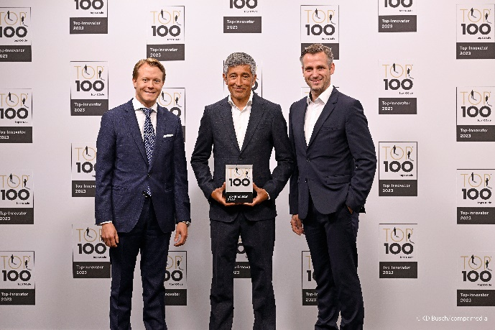
Image 1: Mathias Stendtke and Roland Lenzing (from left) together with Ranga Yogeshwar (centre) at the award ceremony for the TOP 100 seal in June 2023.
(Source: KD Busch/compamedia)

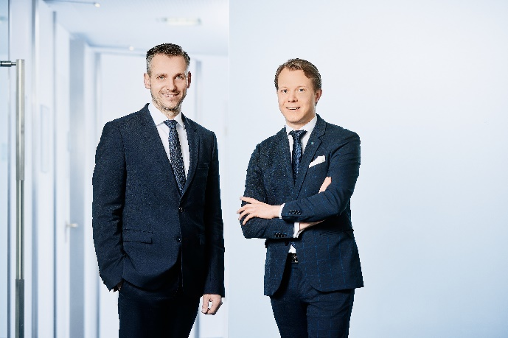
Image 2: Managing Partners Roland Lenzing and Mathias Stendtke are delighted with the TOP 100 award. (Source: PFLITSCH)

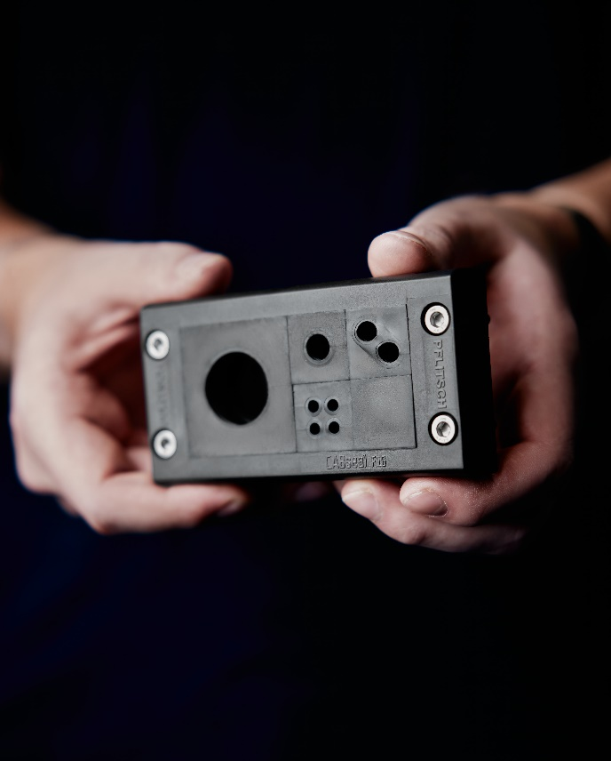
Image 3: Always in step with the times: the newest addition to the PFLITSCH product range. CABseal, the splittable cable entry. (Source: PFLITSCH)

