Cost-effective and precise assembly of PFLITSCH cable trunking

Special machines enable more efficient processing of cable trunking

HÜCKESWAGEN – Steel or stainless steel cable trunking facilitates safe and clear cable routing. PFLITSCH has efficient machines and tools to support engineering companies who prefer to cut, shape and install their cable trunking themselves.

Cable trunking is frequently adapted to different installation situations by cutting it to length with a saw or Flex. This is complicated and time-consuming – and it means more work as well as a greater risk of injury for the fitter. PFLITSCH’s new tools and machines provide a groundbreaking solution that makes work processes more efficient and scores with a rapid return on investment.

PFLITSCH machines make processing cable trunking incredibly simple and safe: the trunking bodies and covers are pushed into the contours in the cutting plate, then secured and cut to length in next to no time. No complex reworking is necessary because the cut parts have clean, low-burr edges. What’s more, the trunking keeps its shape throughout.

MiniCut – for PIK-Trunking

The compact PIK-Trunking system is considered a better option than installation in conduits because it can be opened over its entire length to allow cables to be laid. Using the new MiniCut (Photo 1), trunking can be cut cleanly to anything from 15/15 mm to 60/60 mm. The cutter can be operated with a manual or manual hydraulic drive or with a mains-operated or battery-powered hydraulic unit. Since very little physical effort is needed, the cutting process becomes child’s play even with a manual drive.

MultiCut – customised cutting plates for customer trunking

The new MultiCut (Photo 2) was developed by PFLITSCH for customers who want to process multiple cable trunking systems belonging to the Industrial-Trunking, PIK-Trunking and VARiOX-Trunking series, often in different sizes, on a single machine. The cutting plates for these systems are individually tailored to each customer’s needs. Each cutting plate can have different contours depending on the cable trunking cross-section, e.g. 60 mm x 60 mm for PIK-Trunking, 75 mm x 75 mm for Industrial-Trunking and 100 mm x 100 mm for VARiOX-Trunking. The MultiCut, too, can be operated with a manual or manual hydraulic drive or with a mains-operated or battery-powered hydraulic unit.

MaxiCut – for efficient, high-volume cutting

Engineering manufacturers where many different cable trunking systems are assembled serially take advantage of the MaxiCut with an integrated hydraulic unit (Photo 3). The handy workshop trolley, with a workbench and a large work table, has space for storing all the required cutting plates for Industrial, PIK and VARiOX-Trunking as well as drawers for tools. A height-adjustable support surface helps to align the cable trunking sections precisely during cutting.

Customers choosing these tools save time and money when installing their trunking, leading to greater cost effectiveness. They also achieve more efficient use of materials and reduce the amount of waste, because the trunking can be precisely positioned before it is cut and aligned at a 90° angle. And since these machines provide effortless and safe handling, fitters profit from improved occupational safety.

An online payback calculator (“Amortisationsrechner”) – in German only under www.pflitsch.de/service – helps customers determine easily how long it will take them, with their specific project volume, to recover the cost of purchasing a PFLITSCH machine.

More information on the new machines are available here:
https://www.pflitsch.de/de/kabelfuehrung/maschinen-und-werkzeuge/
Contact:

PFLITSCH GmbH & Co. KG

Ernst-Pflitsch-Str. 1

42499 Hückeswagen, Germany

Phone: +49 (0)2192 9110

E-mail: info@pflitsch.de

Web: www.pflitsch.de

PFLITSCH – the company

PFLITSCH is the global market leader when it comes to industrial cable management. True to our corporate slogan “Passion for the best solution”, we have developed a perfectly coordinated and holistic system of innovative solutions for cable routing, cable entry and cable protection. In this way, we ensure maximum safety and efficiency across a wide range of different industries and application areas that make the highest of demands.

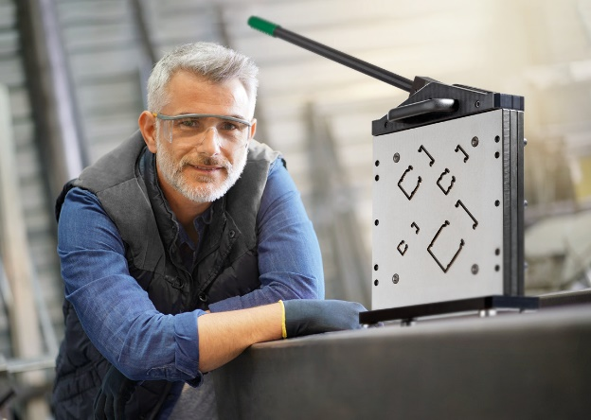
Photo 1: The MiniCut is designed for cutting the 10 cross-sections of the compact PIK-Trunking system – manually, mains-operated or battery-powered.
(Photo: PFLITSCH)

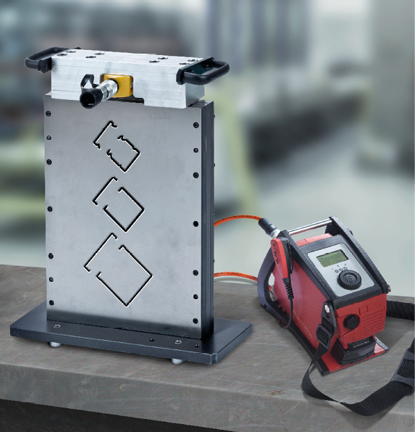
Photo 2: The cutting plates for the new MultiCut are individually manufactured by PFLITSCH depending on the customer’s trunking systems, for example 60 mm x 60 mm for PIK-Trunking as shown here, 75 mm x 75 mm for Industrial-Trunking and 100 mm x 100 mm for VARiOX-Trunking. (Photo: PFLITSCH)

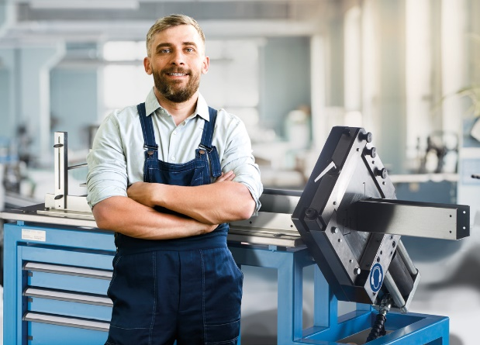

Photo 3: The MaxiCut for high-volume cutting is accommodated in a handy workshop trolley with a workbench and features an integrated electrohydraulic drive. (Photo: PFLITSCH)

