PFLITSCH combines TRI and IRIS concepts to create a customer-specific solution

Assembling and routing multiple cables in an EMC-compliant manner

HÜCKESWAGEN – To enable several cables to be installed EMC-compliantly in just a single cable entry, PFLITSCH has made adaptations to its Multiple solution from the UNI Dicht modular system so that it can be deployed for demanding EMC applications. This concept features ease of assembly, reliability and compactness.

At points where cables are routed through the enclosure of a control cabinet, a gap can arise in the shielding through which electromagnetic waves can “slip through”. PFLITSCH reliably closes this gap with a space-saving, EMC-compliant multiple cable gland that is manufactured to match the cable cross-sections used in a customer’s installation precisely: the UNI Dicht Multiple TRI. In this gland, PFLITSCH combines the shielding and sealing functions of its UNI Dicht and blueglobe cable gland series. This means that even in compact system enclosures with limited space, several shielded cables can be reliably sealed and provided with an EMC-compliant bond using just a single EMC cable gland. This is a unique solution in the marketplace.

TRI spring reliably contacts individual cables

The Multiple concept comes from the UNI Dicht series and enables several cables – even of differing cross-sections – to be reliably fed through a single hole in an enclosure. Positioned immediately behind the sealing insert in the gland is a precision-fit metal disc custom-made for the cable cross-sections being used by the customer. Inside this disc, a TRI spring for each shield of each cable ensures 360° contact. An annular IRIS spring washer ensures reliable bonding of the metal disc with the gland body. PFLITSCH custom-manufactures this solution in sizes from M25 to M63. The UNI Dicht Multiple TRI complies with protection class IP 68 and is approved for the temperature range from –40 °C to +130 °C. To provide all-round mechanical protection, the cable gland can also be combined with PFLITSCH’s ProTect corrugated conduit system.

Dependable assembly
The assembly process is also simple and dependable. For all the user needs to do is remove the cable sheath at the contact point where the shielding braid will later be bonded with the gland. As the cable is pushed into the cable gland, the TRI spring ensures good shield bonding – even with out-of-round or off-centre cables. In any case, PFLITSCH’s principle means that the cable shield only has to be exposed at the actual connection point inside the control cabinet. In this way, maximum attenuation levels are achieved and unwanted coupling of signals and noise avoided.

With this concept, PFLITSCH also mechanically separates the shielding from the seal, because no significant forces act on the contact point when the pressure screw is tightened and the shielding braid remains intact. And the design of the spring element prevents it from snagging in the braid. PFLITSCH’s EMC cable glands can play a decisive role in a plant’s EMC protection concept and they can be crucial when it comes to preventing electromagnetic interference and production downtimes.

Contact:

PFLITSCH GmbH & Co. KG

Frauke Ulrich (Marketing Consultant)

Ernst-Pflitsch-Str. 1, 42499 Hückeswagen, Germany

Phone: +49 (0)2192 9110

E-mail: info@pflitsch.de

Web: www.pflitsch.de

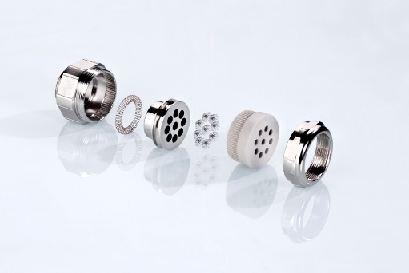

Photo: Positioned immediately behind the multiple sealing insert in this PFLITSCH cable gland is a metal disc with holes that precisely match the cables used. The shielding braid of each of these cables is bonded with the gland by a TRI spring to provide an EMC-compliant connection. (Photo: PFLITSCH)

