HV vehicle electrical systems demand high interference immunity

Electric, hybrid and hydrogen drive systems, with their high-voltage vehicle electrical systems, make high demands on reliability, the tightness of seal and EMC shielding for the cabling alone. Cable routing specialist PFLITSCH has developed special cable entries specifically for this purpose.

Developers of modern vehicle technology are focusing on creating cabling that has to meet the highest safety standards and function safely over the long term. The HV and control cables used, designed for high load capacities and vibration resistance, are fed into the enclosures of batteries, motors and control housings via high-quality cable glands to ensure comprehensive system safety and reliability.

Reliable control of high currents and interference signals

The goal of maximising cruising ranges, minimising charging times and making power electronics as efficient as possible presents the industry with immensely challenging tasks. The various components installed in vehicles generate electromagnetic interference signals that can have a sustained effect on the system as a whole. These include battery modules, electric motors, inverters and DC/AC converters. The high packing density of the installed modules and the combination of low and high voltages in the vehicle do the rest. The reliable discharge of high-frequency interference radiation and of the sometimes very high currents induced in the cable shield must be ensured under all conditions. Particularly in the case of commercial vehicles with an alternative drive system, two- to three-digit shield currents frequently occur that push the cable shields’ current-carrying capacity to its limit.

Exceedingly high attenuation values and current-carrying capacity

PFLITSCH has faced up to these challenges by developing EMC cable glands targeted specifically at the electromobility sector, glands that boast high screening attenuation and an outstanding current-carrying capacity: its AE blueglobe TRI HTS gland series. These components also feature silicone sealing inserts for maximum thermal shock resistance and a design that conforms to the corrosion resistance requirements of VDA 233-102.

Low contact resistances between the cable shield and the contact point prove to be particularly advantageous and effective when it comes to reliably discharging high currents. Thanks to the TRI spring, these PFLITSCH solutions exhibit 360° contact with a large area of the shielding braid of the cable, guaranteeing low resistance levels and long-lasting stability.

In addition, fast and dependable assembly involving just a small number of parts is a yet another advantage of PFLITSCH’s EMC cable glands. And there’s no need for complicated crimping procedures or special tools.

PFLITSCH cable entries are vibration-resistant and can withstand extreme temperature changes, UV radiation, as well as weather, chemical and mechanical stresses such as stone throw.

The TRI cable glands are designed to accommodate the different cross-sections of single and multicore HV cables and large sealing and screening ranges can be covered by just a single size of cable gland.

With two bronze TRI springs connected one behind the other, the AE blueglobe D-TRI NM HTS offers yet more advantages, such as low-impedance discharge of three-digit shield currents. In tests, the M25 gland reliably withstood a constant 200 A for one hour and an intermittent peak value of 380 A for 15 minutes. In addition, this variant impresses with a very high screening attenuation even with high-frequency interference radiation of up to 1 GHz

More information on the new machines are available here:

https://www.pflitsch.de/de/kabelfuehrung/maschinen-und-werkzeuge/

Contact:
PFLITSCH GmbH & Co. KG
Frauke Ulrich/Press
Ernst-Pflitsch-Str. 1
42499 Hückeswagen, Germany
Phone: +49 (0)2192 911180
E-mail: frauke.ulrich@pflitsch.de
Web: www.pflitsch.de

PFLITSCH – the company

PFLITSCH is the global market leader when it comes to industrial cable management. True to our corporate slogan “Passion for the best solution”, we have developed a perfectly coordinated and holistic system of innovative solutions for cable routing, cable entry and cable protection. In this way, we ensure maximum safety and efficiency across a wide range of different industries and application areas that make the highest of demands.

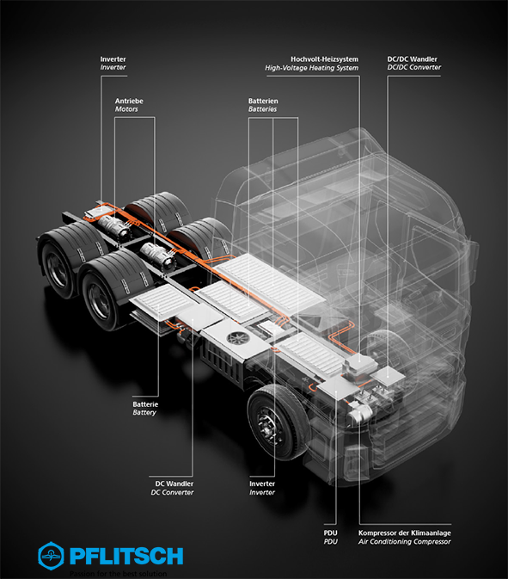
Photo 1: In practice, electric drive systems, with their high-voltage battery modules, powerful electric motors and various electronic components, need reliable, trouble-free and durable cabling – a typical application scenario for high-quality PFLITSCH cable glands. (Photo: PFLITSCH)

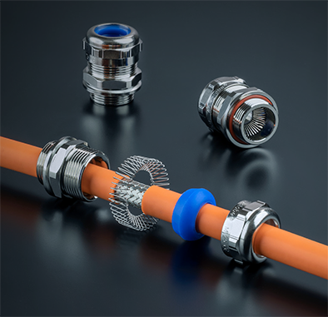

Photo 2: PFLITSCH AE blueglobe HTS series of EMC cable glands offer truly impressive benefits: 360° shield bonding for high attenuation values up into the GHz range, a durable design, as well as large sealing ranges. (Photo: PFLITSCH)

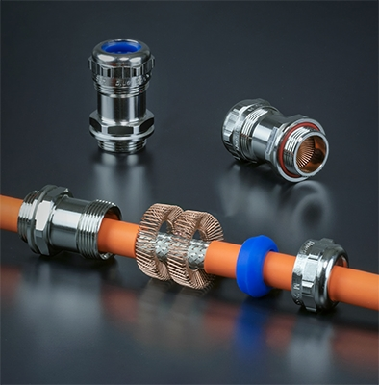

Photo 3: With two bronze TRI springs positioned one behind the other, the AE blueglobe D-TRI NM HTS can reliably discharge low-impedance, three-digit shield currents. (Photo: PFLITSCH)

