PFLITSCH Wire-tray Trunking is easy to assemble

Open installation system offering great flexibility, including for hygienic applications

PFLITSCH’s open and robust Wire-tray Trunking offers optimum cable routing solutions for demanding sectors such as telecommunications and information technology, the food industry as well as for chemical, mechanical and plant engineering. The system is also UL- and DNV-approved for use in demanding offshore installations.

PFLITSCH Wire-tray Trunking is available in sizes from 53 mm x 46 mm to 620 mm x 110 mm and heights of 60 mm and 110 mm, and also as U-, C-, G-shaped and flat Mini Wire-tray Trunking from 40 mm x 20 mm. New is Z-shaped trunking designed for applications in the food and pharmaceuticals industries, where installations must be easy to clean.

The Wire-tray Trunking is made of up to 6mm-thick galvanised steel or stainless steel wires for best corrosion protection and high strength. It can be custom-assembled with the aid of just two tools. Sections of wire that are not needed are simply cut away and the trunking bent into the required shape. The individual segments are screwed together with connectors so that the trunking forms a strong cable routing system.

Wide range of accessories and special solutions

Insertable bending plates and radius limiters safely guide cables through transitions and around bends. Separating walls ensure clear cable routing, while mounting plates enable components to be attached directly to the Wire-tray Trunking. Roof-shaped or flat clip-on covers – also available as a fully protected variant with side covers – protect the cables laid in the trunking from liquids that may drip from above.

For applications in the food industry where thorough cleaning is essential, PFLITSCH has developed special fixing brackets especially for its Wire-tray Trunking so that the trunking can be installed as hygienically as possible.

Using the electrohydraulic, battery-powered Wire-tray Trunking shears, wires that are not wanted can be cut out of the trunking cleanly and in a matter of seconds simply by pressing a button. This special tool makes low-burr cuts that require absolutely no time-consuming and costly reworking. The 330°-rotatable tool head is easy to use, even on already installed Wire-tray Trunking. The high-performance battery can be recharged in just 15 minutes.

Process optimisation on site thanks to pre-assembled component assemblies

The component assembly service available from PFLITSCH offers great savings potential. From planning through purchasing and logistics to assembly, this service results in a high level of process optimisation and cost transparency for the customer. The cable trunking is planned on screen in 3D using PFLITSCH’s easyRoute tool and it can be integrated virtually into the machine environment. PFLITSCH uses the design data as the basis for costing, quotation preparation and production. This results in pre-assembled trunking component assemblies that PFLITSCH delivers on time at a fixed price. Fitters can then install the numbered assemblies easily and safely. Once designed, the component assemblies can be reproduced, reordered and even modified at any time.

Contact:

PFLITSCH GmbH & Co. KG

Ernst-Pflitsch-Str. 1

42499 Hückeswagen, Germany

Frauke Ulrich (Marketing Consultant)

Phone: +49 (0)2192 9110

E-mail: info@pflitsch.de

Web: www.pflitsch.de

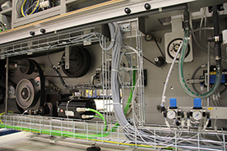
Photo 1: PFLITSCH’s Wire-tray Trunking provides open and clear cable routing in mechanical engineering applications. Cables can enter and exit at any point. (Photo: PFLITSCH)

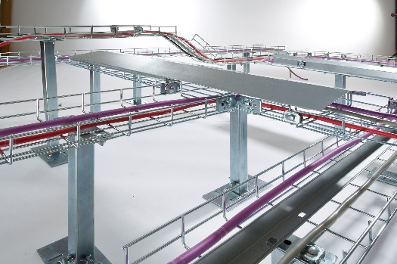
Photo 2: PFLITSCH’s open and robust Wire-tray Trunking offers optimum cable routing solutions for demanding sectors such as telecommunications, the food industry as well as for chemical, mechanical and plant engineering. (Photo: PFLITSCH)

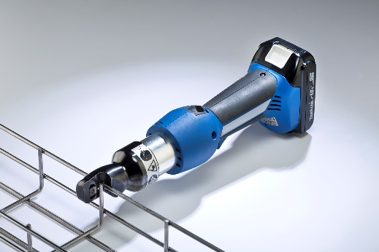
Photo 3: The practical battery-powered tool makes it easy to cut out unwanted wires during installation. (Photo: PFLITSCH)

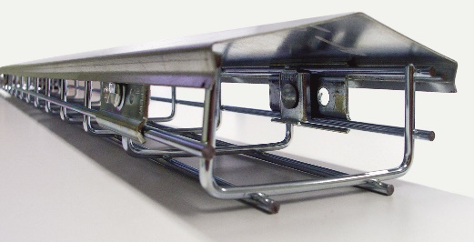
Photo 4: A clip-on cover turns the Wire-tray Trunking into a protective space for sensitive cables, such as in hygienic applications. (Photo: PFLITSCH)

