PFLITSCH Industrial-Trunking for installing a wide variety of cables

Customised and safe routing of bus lines to power cables

Automated processes and machinery required large numbers of data lines, control and power cables to be routed through plants. Safety, ease of assembly and modifiability are just three of today’s user demands.

With 13 different cross-sections ranging from 50 mm x 50 mm to 600 mm x 150 mm (W x H) and around 80 accessory fittings per size, PFLITSCH’s Industrial-Trunking enables greatly differing volumes of cables to be routed reliably in industrial environments. The closed cable trunking sections, made of sheet steel, aluminium or stainless steel, protect the cables over the entire route and have removable or hinged covers that are securely locked to the trunking body by means of a rotary, hinged or toggle joint fastener. Cables can be easily inserted and removed at every point along the trunking, making it easy to make any necessary modifications to the already installed cables.

The actual trunking sections are bolted together in a vibration-proof manner using press-fitted, self-securing lock nuts. Various corner connectors, T connections and crossings, adjustable bends and elbows, etc. are available as accessory fittings. Height and width variations can be reliably compensated with the aid of telescopic and hose parts. This means that any and even complex trunking layouts can be implemented in a plant without any limitations.

The low-burr design of the trunking and the comprehensive edge protectors available for lateral cut-outs and end fittings protect cables from becoming damaged. Telescopic components and adjustable elbow accessory fittings can be used to simply and reliably compensate the dimensional deviations in a machine. Clip-in separating walls are available to facilitate clearly structured and orderly routing of data, control and power cables as well as other lines.

Equipotential bonding between sections of trunking and accessory fittings is achieved automatically when the elements are screwed together using pawl safety screws. Trunking covers are integrated in a potential-free manner by means of equipotential bonding straps and locking straps.

Ideal configuration and simple pre-assembly

In order to cut the individual cable trunking sections to length to construct the trunking system desired and to provide the system with cut-outs, outlets and other details, PFLITSCH has a number of practical tools such as the MaxiCut. With the aid of this workshop machine, cable trunking bodies and covers can be cut to length with to-the-millimetre precision, at the push of a button, and low-burr cut-outs can be created at the sides of the trunking – cleanly and with less noise compared to conventional cutting methods. The machine is the perfect choice when a lot of trunking sections need to be cut. A new concept launched by PFLITSCH is that of the MultiCut, with its customisable cutting plates. This cutting machine enables several sizes of trunking to cut using just one cutting plate. The cutting plates are custom-made so that users can enjoy the greatest degree of flexibility possible in their day-to-day work. With the aid of our payback calculator – which can be downloaded from www.pflitsch.de – and concrete data, you can calculate how quickly your investment in these machines will pay off.

Process optimisation on site thanks to pre-assembled component assemblies

The component assembly service available from PFLITSCH offers even greater convenience and savings potential. From planning through purchasing and logistics to assembly, this service results in a high level of process optimisation and cost transparency for the customer. The cable trunking is planned on screen in 3D using PFLITSCH’s easyRoute tool and it can be integrated virtually into the machine environment. PFLITSCH uses the design data as the basis for costing, quotation preparation and production. This results in pre-assembled trunking component assemblies that PFLITSCH delivers on time at a fixed price. Fitters can then install the numbered assemblies easily and safely. Once designed, the component assemblies can be reproduced, reordered and even modified at any time.

Contact:

PFLITSCH GmbH & Co. KG

Ernst-Pflitsch-Str. 1, 42499 Hückeswagen, Germany

Frauke Ulrich (Marketing Consultant)

Phone: +49 (0)2192 9110, e-mail: info@pflitsch.de

Web: www.pflitsch.de
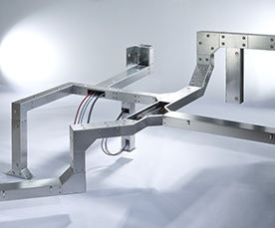
Photo 1: PFLITSCH steel and stainless steel Industrial-Trunking offers a wide range of potential applications thanks to 13 different cross-sections and around 80 accessory fittings. (Photo: PFLITSCH)

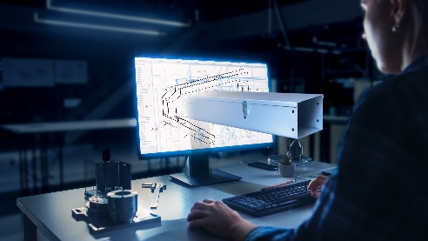
Photo 2: The easyRoute tool is used to design the route of a trunking system in the planned machine environment on the CAD screen. The resulting data is used in purchasing, production and assembly to guarantee transparency and process reliability.
(Photo: PFLITSCH)

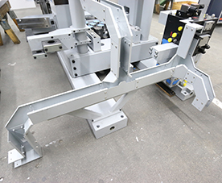
Photo 3: PFLITSCH realizes such component assemblies on behalf of the customer and delivers them on the agreed date, ready for installation and at a fixed price. (Photo: PFLITSCH)

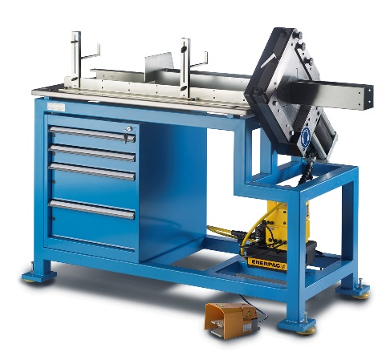

Photo 4: Thanks to customised cutting plates, the MaxiCut can be used to cut trunking bodies and covers to length precisely and burr-free – with an electrohydraulic drive system. (Photo: PFLITSCH)

Photo 5: The cutting plates of the MultiCut cutting machine are custom-made, enabling the machine to be perfectly adapted to the respective application. A longitudinal stop and infeed aid are also available as options to make it easy to align and position the sections of cable trunking to be cut. (Photo: PFLITSCH)

