PFLITSCH installation trunking – the solution for small volumes of cables

The perfect all-round protection for small volumes of cables and fibre optic cables

The increasing degree of automation of machinery and equipment requires a large number of different types of cable to be routed reliably and safely around industrial environments. As a superior alternative to laying pipes, PFLITSCH installation trunking – PIK, for short, from the German – combines the advantages of the company’s large trunking systems with removable covers with a compact design, so that individual cables, e.g. to sensors, can also be laid in a protected manner.

Thanks to the thickness of the sheet steel it is made of and the creases in the side walls, PIK is lightweight and yet very dimensionally stable. Unlike cabling systems that use piping, PIK-Trunking can be opened along its entire length, making it easier to insert additional cables or upgrade an installation. Its cover is simply clipped on and, thanks to its tight fit, sits securely even when the trunking is installed vertically and subject to vibration.

PIK is available in ten cross-sections from 15 mm x 15 mm to 200 mm x 60 mm. Elbows, T connections and other accessory fittings enable enclosed cable routing in all directions as well as around corners and at junctions. Connectors provide equipotential bonding between all trunking components. Separating walls keep power and data cables apart in accordance with EMC requirements.

Captive end caps and edge protectors for lateral cut-outs prevent damage to cables even in the event of vibration. By installing with retaining clips into which the PIK-Trunking is simply clipped, tolerances in the installation area can be compensated. The trunking can also be assembled with screws. The low-burr design of the PIK protects the cables run through it against damage.

PIK-Trunking is available in galvanised sheet steel, primed and powder-coated in RAL colours of your choice, as well as in stainless steel, e.g. for hygienic applications.

Ideal configuration and simple pre-assembly

In order to cut the 3 m long PIK sections to length to construct the trunking system desired and to provide the system with cut-outs, outlets and other details, PFLITSCH has practical tools such as the new MiniCut with lever, which requires 2/3 less effort to cut trunking compared to previous solutions. Also new is the MultiCut concept for customisable cutting plates and operation by means of a lever, manual hydraulic or electrohydraulic drive. In addition to contours for cutting the PIK-Trunking to length, contours for other models of PFLITSCH cable trunking can also be integrated in the cutting plate of the MultiCut – giving users greater flexibility and the ability to expand potential applications.

With battery-powered and hand-operated tools, PFLITSCH also offers the option of cutting and modifying existing trunking systems with ease. With the aid of our payback calculator – which can be downloaded from www.pflitsch.de – users can easily calculate the cost-effectiveness of the tools based on their own concrete data.

Process optimisation on site thanks to pre-assembled component assemblies

The component assembly service available from PFLITSCH offers even greater convenience and savings potential. From planning through purchasing and logistics to assembly, this service results in a high level of process optimisation and cost transparency for the customer. The cable trunking is planned on screen in 3D using PFLITSCH’s easyRoute tool and it can be integrated virtually into the machine environment. PFLITSCH uses the design data as the basis for costing, quotation preparation and production. This results in pre-assembled trunking component assemblies that PFLITSCH delivers on time at a fixed price. Fitters can then install the numbered assemblies easily and safely. Once designed, the component assemblies can be reproduced, reordered and even modified at any time.

Contact:

PFLITSCH GmbH & Co. KG

Ernst-Pflitsch-Str. 1, 42499 Hückeswagen, Germany

Frauke Ulrich (Marketing Consultant)

Phone: +49 (0)2192 9110

E-mail: info@pflitsch.de

Web: www.pflitsch.de

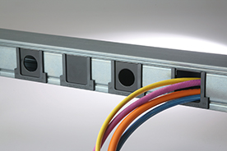
Photo 1: Compact PIK-Trunking, as an alternative to piping, can be opened completely to allow cables to be removed or additional cables to be run. Cut-outs are fitted with edge protectors to protect the cables. (Photo: PFLITSCH)

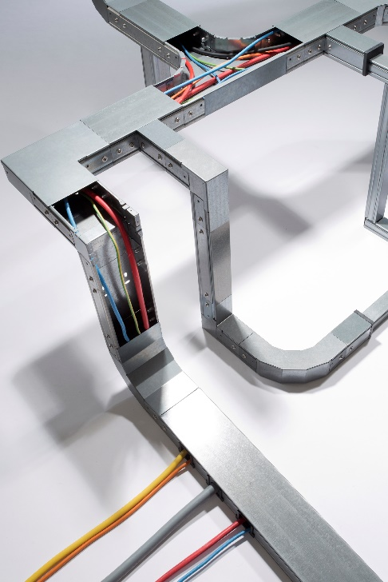
Photo 2: PFLITSCH realises such PIK component assemblies on behalf of the customer and delivers them on the agreed date, ready for installation and at a fixed price. (Photo: PFLITSCH)

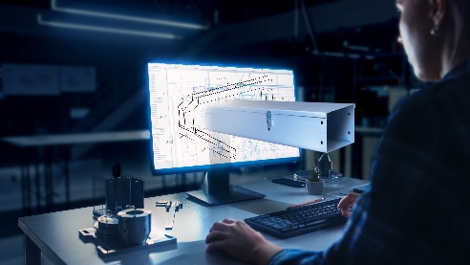
Photo 3: The easyRoute tool is used to design the route of a trunking system in the planned machine environment on the CAD screen. The resulting data is used in purchasing, production and assembly to guarantee transparency and process reliability.
(Photo: PFLITSCH)

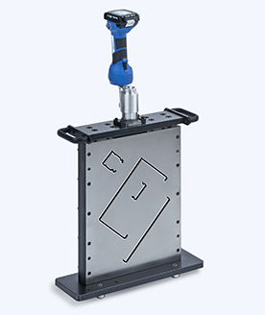

Photo 4: With the new MultiCut tool – driven in this case by a rechargeable battery system – PIK-Trunking bodies and covers can be cut to length precisely and burr-free in a matter of seconds. (Photo. PFLITSCH)

