For the safe routing of cables through the train roof and wall

Safe corrugated conduit transit for railroad technology
If corrugated tubes have to be guided safely in rail vehicles, e.g. through the roof or wall, the new UNI corrugated conduit transit from PFLITSCH is used. Its advantages: Corrugated tubes can be continued and sealed without further fittings. Optionally, it is also possible to let the corrugated conduits end with the cable gland and not to lead them further.
The screw fitting body made of nickel-plated brass is available in six sizes (M20-M63). The sealing insert encloses corrugated tubes over a large area and gently, so that protection class IP68 up to 10 bar is reliably achieved. The compact bushings are suitable for corrugated tubes with fine and coarse profiles in nominal sizes 10-48.
Thanks to a special fire protection silicone in the sealing insert, the corrugated tube bushings meet the requirements of fire protection standard EN 45545, hazard level HL3, and cover the temperature range from -55°C to +180°C. The "on block" assembly also makes installation simple and safe. PFLITSCH realizes further variants on customer request.

ContaCt:

PFLITSCH GmbH & Co. KG

Frauke Ulrich / Press

Ernst-Pflitsch-Str. 1, D - 42499 Hückeswagen

Phone: +49 2192-911-920

E-Mail: fraukesolveig.ulrich@pflitsch.de

Web: www.pflitsch.de

BESUCHEN SIE UNS:

Image 1: UNI corrugated conduit transit for railway industry © PFLITSCH GmbH & Co. KG
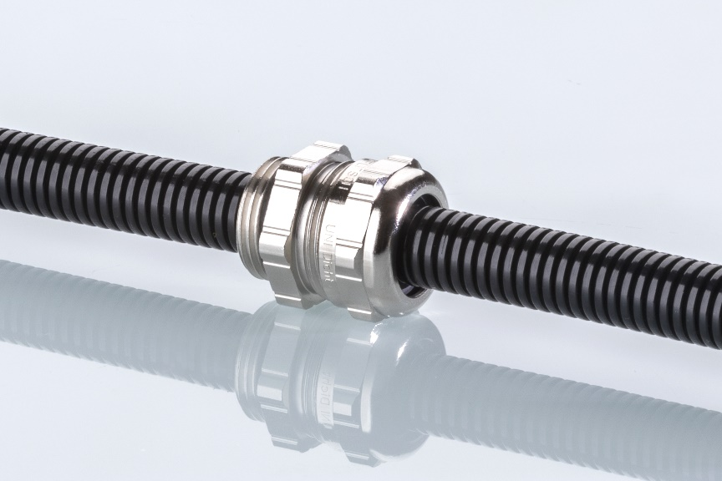

Image 2: UNI corrugated conduit transit (explosion view) for railway industry © PFLITSCH GmbH & Co. KG
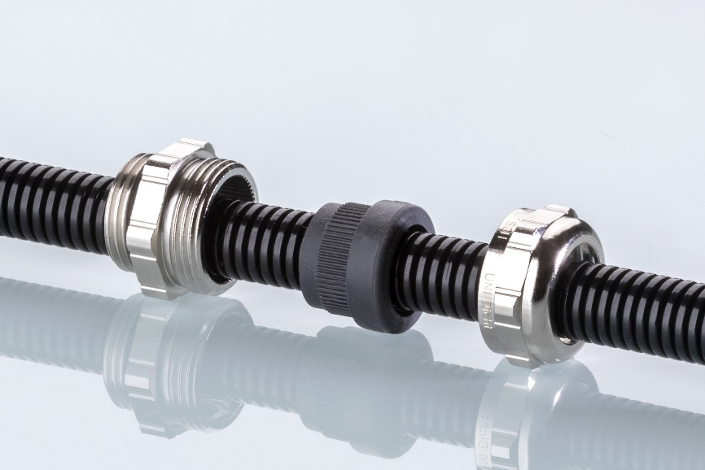

Image 3: UNI corrugated conduit transit for railway industry in application © PFLITSCH GmbH & Co. KG

