TRI spring technology from PFLITSCH integrated in the UNI Dicht system
Achieving maximum EMC shielding with a minimum size
The demands placed on EMC cable glands are multifaceted: they must not only effectively dissipate electromagnetic interference fields, but also undesirably high shield currents. Furthermore, compact dimensions are needed to fit them in limited installation spaces. In response to market requirements, EMC cable glands also need to be simple, quick and dependable to install. Addressing these needs, the new UNI Dicht TRI from PFLITSCH combines the top EMC bonding capabilities of the TRI spring – familiar from the blueglobe series – with the compactness and individuality of the UNI Dicht modular system.
The UNI Dicht TRI achieves maximum screening attenuation across the entire frequency range, facilitated by its patented triangle spring that enables 360° bonding with the cable shield over a large area. The mechanical separation of the shield contacting from the sealing element guarantees constant and enduring EMC properties for the UNI Dicht TRI. A further advantage is the very high current carrying capacity that reliably dissipates undesirably high shield currents thanks to the large contact area of the solid stainless steel TRI spring.
Dependable assembly
The assembly process is both straightforward and reliable. All the user needs to do is to remove the cable sheath at the contact point where the shielding braid is to be bonded. The TRI spring reliably bonds the cable shield as soon as the cable is inserted in the cable gland – even with out-of-round or off-centre cables. Importantly, this bonding method from PFLITSCH means that the cable shield only needs to be exposed at the actual connection point inside the control cabinet. As the shielding braid remains fully intact, maximum screening attenuation is achieved and the useful signals are transmitted without being unnecessarily affected by interference signals.
The interlocking of the double nipple and sealing insert prevents the cable from twisting when the pressure screw is tightened. This feature makes the UNI Dicht TRI particularly suitable for applications where the cable is already bonded, for example connectors and sensors.

Huge screening ranges ensure a reliable EMC connection

The UNI Dicht TRI is available in sizes from M16 to M25 for cable diameters from 4.0 mm to 20.5 mm. Thanks to its large sealing ranges, wide diameters can be reliably sealed with IP 68. The huge screening range of the UNI Dicht TRI furthermore ensures a reliable EMC connection. For example, in the M25 very thin shield diameters from 3 mm up to 17 mm can be bonded. The large sealing area in PFLITSCH cable glands prevents constriction of the cable sheathing to guarantee durable and safe installation. The UNI Dicht TRI made of nickel-plated brass or stainless steel is approved for the temperature range from –40 °C to +130 °C with a TPE sealing insert and from –55 °C to +200 °C with a silicone sealing insert.

PFLITSCH EMC cable glands are an important element of the EMC protection concept for electrical systems, safeguarding against interference and failures.

Contact:

PFLITSCH GmbH & Co. KG

Frauke Ulrich/Press

Ernst-Pflitsch-Str. 1, 42499 Hückeswagen, Germany

Tel.: +49 (0)2192 911 920

E-mail: frauke.ulrich@pflitsch.de

Web: www.pflitsch.de

VISIT US ONLINE:

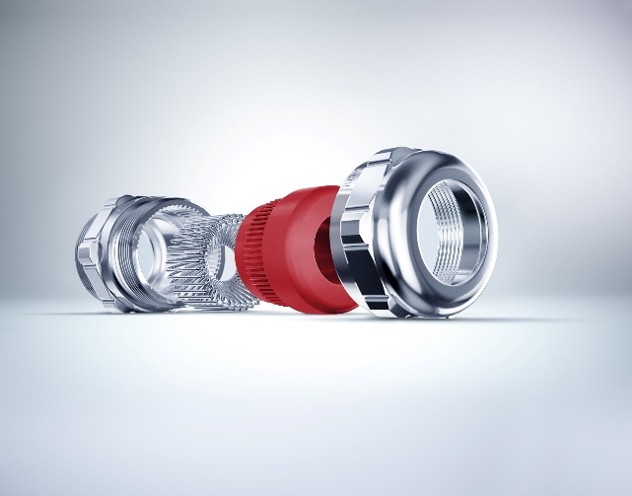
Photo 1: The UNI Dicht TRI expands the comprehensive PFLITSCH range of solutions relating to EMC and helps users to implement a seamless EMC concept. (Photo: PFLITSCH)

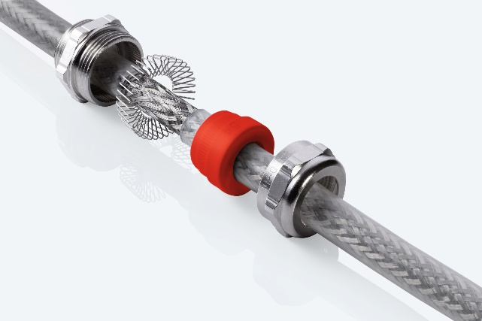
Photo 2: The UNI Dicht TRI cable gland is a compact solution individually assembled from the UNI Dicht modular system, enabling high EMC screening attenuation and a compact design. (Photo: PFLITSCH)

About the company
PFLITSCH is the global market leader when it comes to sophisticated products and services for industrial cable management. True to our corporate slogan “Passion for the best solution”, our family-owned company has created a holistic system of innovative solutions for cable routing, cable entry and cable protection. In this way, we ensure maximum safety and efficiency across a wide range of industries and application areas that make the highest of demands.

