Railway industry in focus
PFLITSCH is a new member of the German Railway Industry Association VDB

PFLITSCH has been a partner to the international railway industry for many years, providing innovative solutions for reliable and durable cable entries. For example, the Hückeswagen-based medium-sized company was a pioneer in the implementation of the fire protection standard EN 45455. As an official member of the German Railway Industry Association (VDB), the company is emphasising its desire to further focus on this industry with its sophisticated technology and to increase its presence in the expanding railway industry. The company plans to participate in working groups and specialist groups in order to drive forward technological developments.

"As a new member, we are proud to be part of this renowned organisation representing the interests of the railway industry. We see it as an incentive to continue on our path and work together in this network to create pioneering solutions for the mobility of tomorrow," says Josef Bauer, Head of Global Key Account Management and Market Transportation at PFLITSCH.

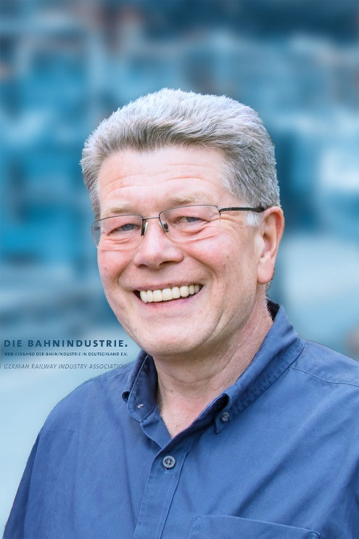
The German Railway Industry Association (VDB) brings together the manufacturers of all products for railway operations under its umbrella, both system houses and medium-sized suppliers. This includes manufacturers of vehicles, control and safety technology, infrastructure and their associated suppliers and services. The VDB member companies stand for world-leading rail innovations "Made in Germany".

Visit PFLITSCH at the InnoTrans in Berlin: Hall 12 Stand 450

Contact:

PFLITSCH GmbH & Co. KG

Frauke Ulrich / Press

Ernst-Pflitsch-Str. 1, D - 42499 Hückeswagen

Phone: +49 2192-911-920

E-mail: frauke.ulrich@pflitsch.de

Web: www.pflitsch.de

VISIT US:
 |  |  | 

About the company
PFLITSCH is the international market leader when it comes to highly developed products and services for industrial cable management. Under the motto "Passion for the best solution", the family-owned company has created a holistic system of innovative solutions for cable routing, cable entry and cable protection. This ensures maximum safety and efficiency in a variety of different industries and application areas with the highest demands.

