PFLITSCH Cleanplus – the hygiene star at Anuga FoodTec
Compact EHEDG-certified cable gland for simple and reliable assembly
With the new Cleanplus, PFLITSCH is adding yet another innovative cable gland to its Hygienic Design portfolio that enables simple assembly and optimum handling, with fewer individual parts and larger sealing ranges per connection thread. This makes it the first cable gland to be certified in accordance with the stricter EHEDG guidelines.
Once again, PFLITSCH has broken new ground in order to meet the stringent EHEDG requirements: the new, certified PFLITSCH Cleanplus Hygienic Design cable gland features a sleek stainless-steel look and can be cleaned to perfection thanks to its EHEDG-compliant design.
Impressive product features
At product launch, the Cleanplus is available in the five standard sizes from M12 to M32. This allows cables from 4.0 to 23.0 mm in diameter to be reliably sealed. The sealing inserts made of HTS silicone have anti-twist protection so that the cable remains securely in position when the pressure screw is tightened. The Cleanplus also scores with a wide temperature range from –55 °C to +180 °C, making it suitable for use in all areas of food, beverage and pharmaceutical production.
Dirt doesn’t stand a chance
The compact Cleanplus made of stainless steel impresses with its smooth surfaces and rounded spanner flats. The gland has been designed to avoid gaps or exposed threads after assembly. The maximum tolerance of +/–0.2 mm for crevices currently required by the EHEDG is complied with. This prevents dirt particles from adhering to parts and means the glands can be cleaned thoroughly.
For the sealing inserts, PFLITSCH uses an Ecolab-certified silicone material in compliance with FDA 21 CFR § 177.2600 that is approved for contact with food. Technical features include compliance with the exacting protection ratings IP 68 and IP 69, a large sealing insert that provides exemplary cable protection and the excellent strain relief that prevents the cable from slipping out of the cable gland.

Contact:

PFLITSCH GmbH & Co. KG

Frauke Ulrich/Press

Ernst-Pflitsch-Str. 1, 42499 Hückeswagen, Germany

Tel.: +49 2192 911-920

E-mail: frauke.ulrich@pflitsch.de

Web: www.pflitsch.de

VISIT US ONLINE:

About PFLITSCH
PFLITSCH is the global market leader when it comes to sophisticated products and services for industrial cable management. True to our corporate slogan “Passion for the best solution”, our family-owned company has created a holistic system of innovative solutions for cable routing, cable entry and cable protection. In this way, we ensure maximum safety and efficiency across a wide range of industries and application areas that make the highest of demands.

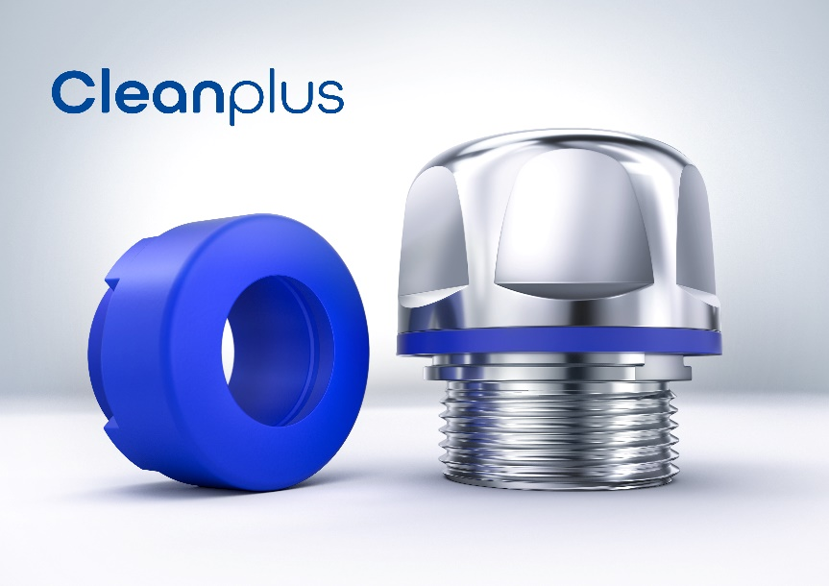
Photo 1: More compact, simpler and more reliable – these are the benefits of the new PFLITSCH Cleanplus Hygienic Design cable gland, certified in accordance with the stricter EHEDG specifications. (Photo: PFLITSCH)

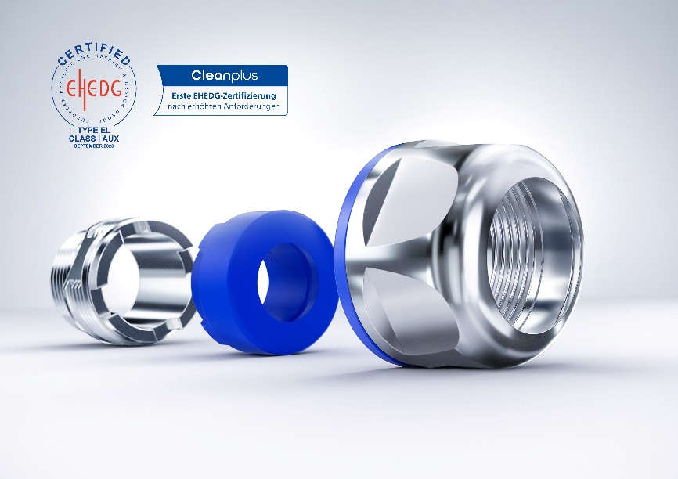
Photo 2: The new Cleanplus requires few components. (Photo: PFLITSCH)

